Michael Glenn (mdg258), Nathan Zhang (nyz4), Siying Cui (sc2863), Carter Zhu (yz553)

**Project Idea:**

Choropleth maps of Asian countries colored based on their total population size, median age, and population growth in 2023. Each country will be shaded based on a color gradient (e.g., light colors for low population, darker colors for high population).

**Possible additional variables:**

1. Gross Domestic Product
2. Life Expectancy
3. Population Growth Rate
   1. <https://data.worldbank.org/indicator/SP.POP.GROW?locations=Z4-AS>
4. Median Age
   1. <https://www.statista.com/statistics/590942/median-age-of-the-population-in-south-east-asia/>
5. Unemployment Rate
6. Internet Penetration
7. CO2 Emissions per Capita
8. Energy Consumption per Capita

**Data:**

Asia: <https://www.worldometers.info/world-population/asia-population/#google_vignette>

World: <https://data.worldbank.org/indicator/SP.POP.TOTL>

Asian Countries (map): <https://en.wikipedia.org/wiki/List_of_Asian_countries_by_population>

SVG Asia map: <https://vemaps.com/asia-continent>

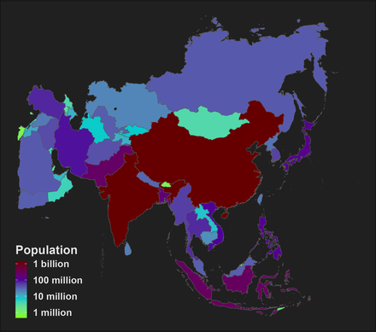

**To-Do:**

**Michael**

* Create dataset (name, population, median age, population growth)
* Match geoJSON and csv names
* Make new geoJSON file

**Carter**

* Choropleth maps of Asian countries colored based on their total population size

**Siying**

* Choropleth maps of Asian countries colored based on their median age

**Nathan**

* Choropleth maps of Asian countries colored based on their population growth